Debugging Log

# Bug 1

The data that is being updated incorrectly is the player’s balance. So after confirming in Main.java that it is stored in the player class, I read the methods of Player.java.

‘balance’ is a class variable integer of the player class, and its references appear here:

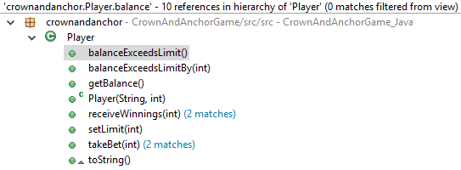

The three times that balance is adjusted are: in the constructor (naturally), in takeBet() and receiveWinnings(). Thanks to intuitive method names I can infer that takeBet() is called before the player’s die pick is compared with the results, and receiveWinnings() is called when the results fall in the player’s favour.

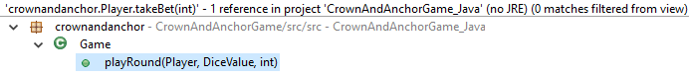

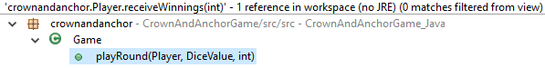

Fortunately both are called only in the one and same method: Game.playRound().

So in all bar one scenario, Player.balance is updated properly. The only time that balance is updated in the normal flow is in Game.playRound(). The bug is most likely to be found here.

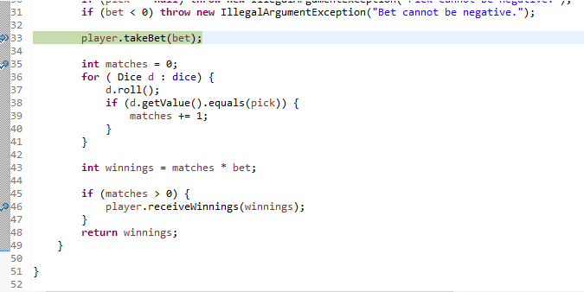

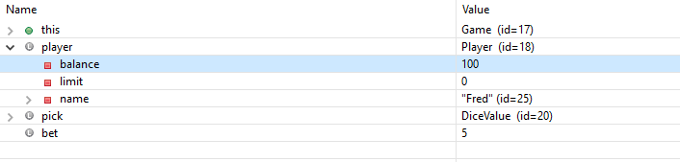

Above is the state of the program at the first call to Game.playRound(). player.balance is set to 100 as it was initialised.

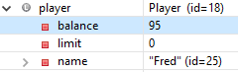

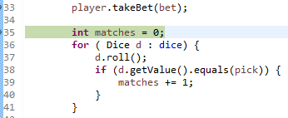

The next breakpoint is just after the first takeBet() call. bet is 5, so takeBet() has subtract 5 from 100. *The player puts down 5 units on their side of choice.*

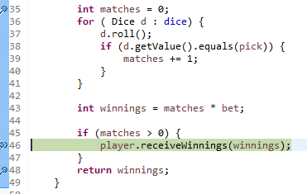

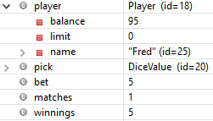

The player has found 1 match, and so their winnings ought to give them 2:1 odds, according to the rules of Crown and Anchor.

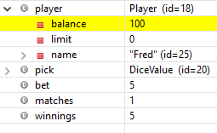

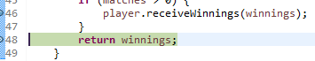

In the next update, 5 has been added to the player’s balance, returning it to 100. We have just seen Bug 1 in action.

This bug is due to a misunderstanding that a net increase of 5 units is the same as adding 5 to the balance after the bet has been placed. The issue is resolved by increasing how much is won by the player on a success.

int winnings = matches * bet;

becomes

int winnings = (matches + 1) * bet;

This is safe because the condition for progressing to player.receiveWinnings() is that matches > 0. This was functional before and has not been changed.

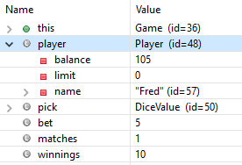

This is the new output of a 1-match win. The initial state was 100, 5 was subtracted as the bet was placed, and then 10 was added after the results were checked.

# Bug 2